How to join quilt binding

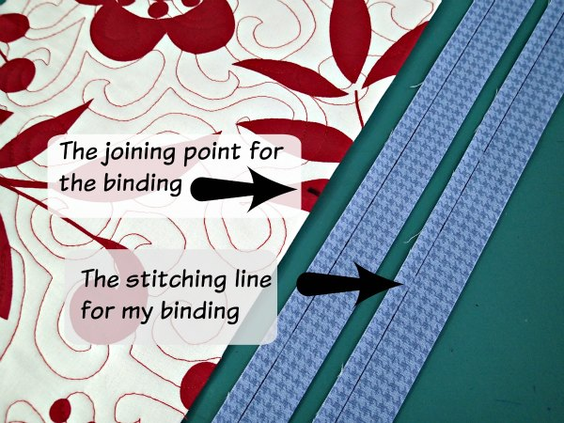
Cut your straight cut binding strips. I'm using 2.5-inch wide binding, folded in half to make it 1 and 1/4th inches wide. I find this works nicely with a 3/8th of an inch seam. If you have a very thick batting you may need to allow a little extra in your strip width for that thickness – test it and see or move your needle to get the seam allowance just right.
First, decide where the approximate join is going to be. If it's pretty invisible that shouldn't matter too much, but don't make it too close to a corner because you'll need space to work. I've marked my join point with a Sharpie so you can see it.
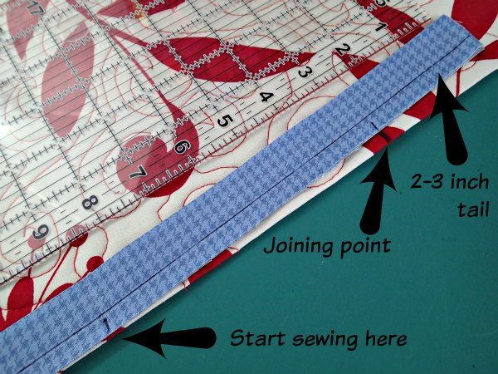
Leave enough of a tail to cover that mark plus about 2-3 inches and then start sewing about 6 inches away from the join mark. Sew on your binding with the 3/8th of an inch seam (or whatever you have chosen for your project), and complete all the way around until you get to the final side again.
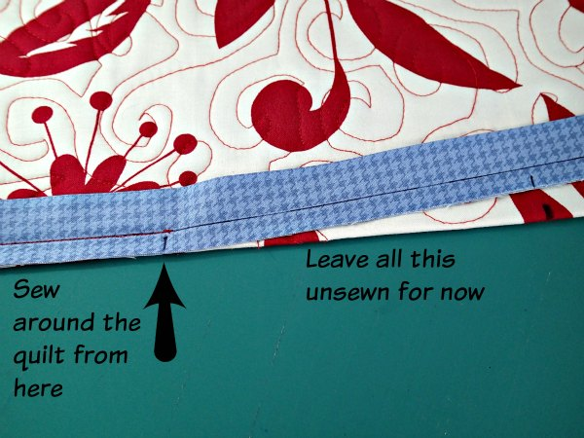
As you approach your joining point from the other side, stop sewing about 6 inches away and make sure you have enough binding left over to go past your joining point by another 2-3 inches.
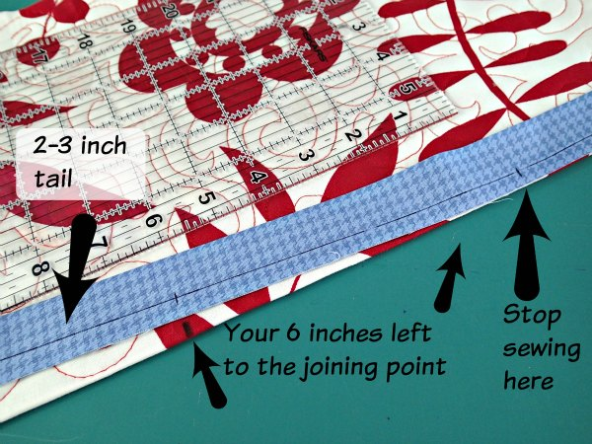
Snip off the extra binding. If you smooth your binding out now, both ends should overlap and go 2-3 inches past the joining point.
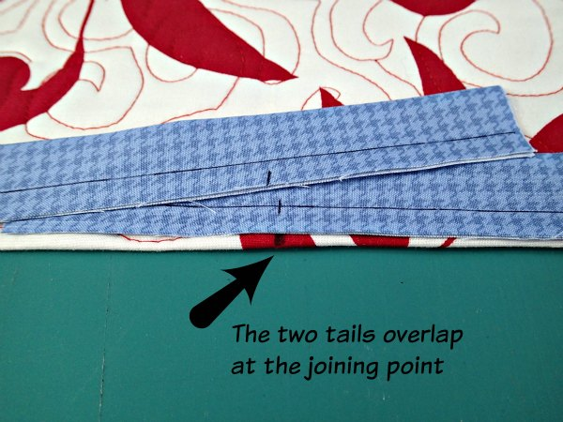
Take some of the extra binding that you have snipped off and open it out to the full 2.5 inches wide. Line up the binding over the join point so the center crease in the binding is right over your join point.
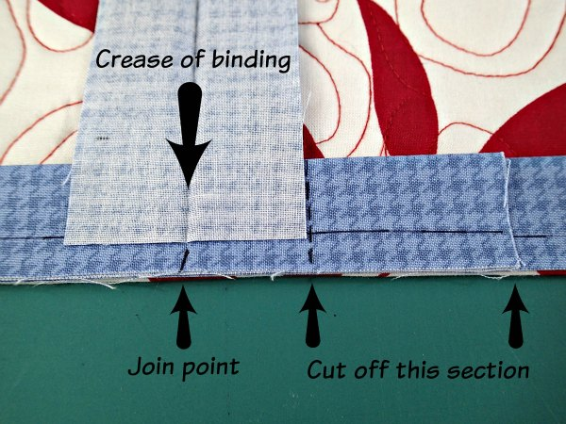
Mark the top piece of binding on the side away from the stitching, and cut off any extra. Fold this piece of binding out of the way now, this is cut to the right length.
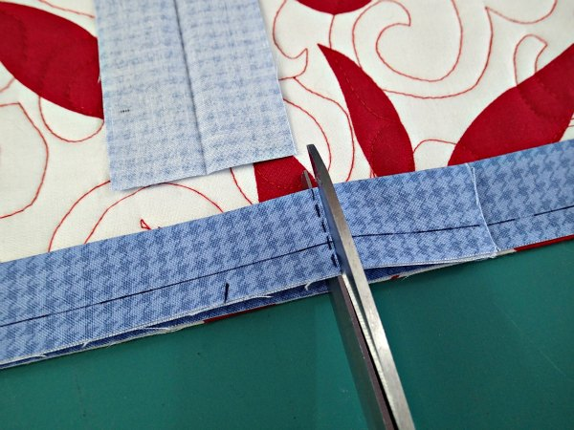
Mark the lower piece of binding on the side opposite to the stitching and cut off the extra. Now if you overlap the two binding pieces they should exactly overlap the same width as the binding strip.
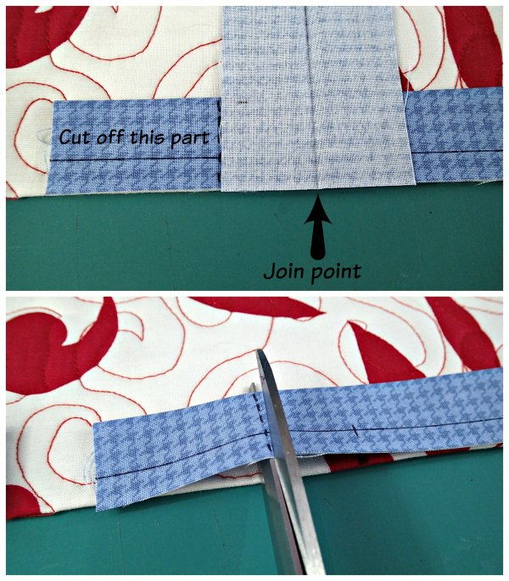
Time to join the two pieces. Fold the quilt in half at the join point to give yourself some working space. Place the two pieces of binding right sides together at a 90-degree angle, matching up the ends nice and square like this. Add a couple of pins if you need to.
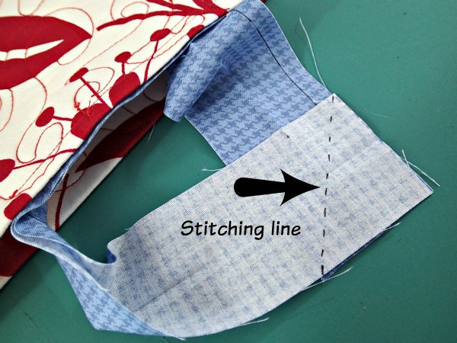
Then sew from the one corner to the other through both layers. To double check which direction to sew, the point should be on the right of your needle and the quilt will be on the left. Open out to check you've done it correctly and if you are happy, cut off the excess fabric leaving a 1/4 inch seam. Press the seam open – finger pressing should be fine.
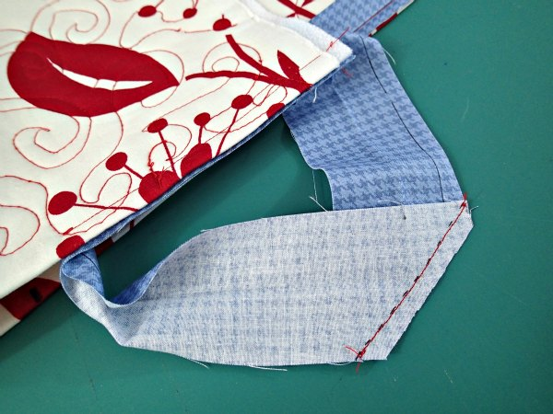
Fold the binding back in half, smooth it out even with the edge of your quilt and sew the gap between the two points of stitching. Your binding should fit in there exactly – like magic!
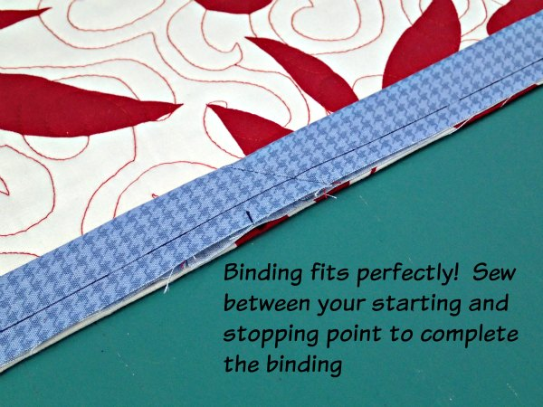
Now you can turn the binding over to the other side and finish, and you'll barely be able to see the join. Obviously use matching thread, not the contrasting thread I used for this example.
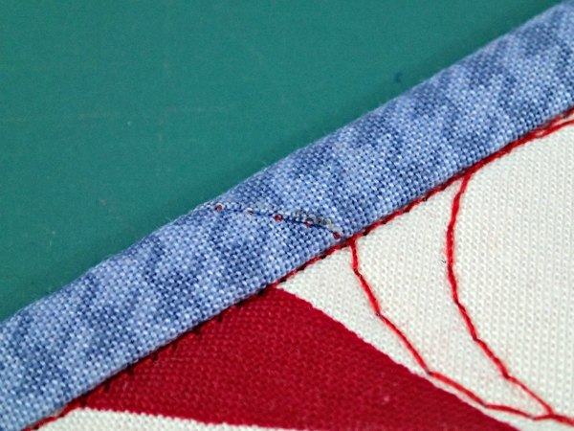
I stitched in the ditch from the front and caught the back of the binding evenly on the reverse. The join is nice and smooth, the binding fitted perfectly with no puckers. Easy when you know how!

